Dakk

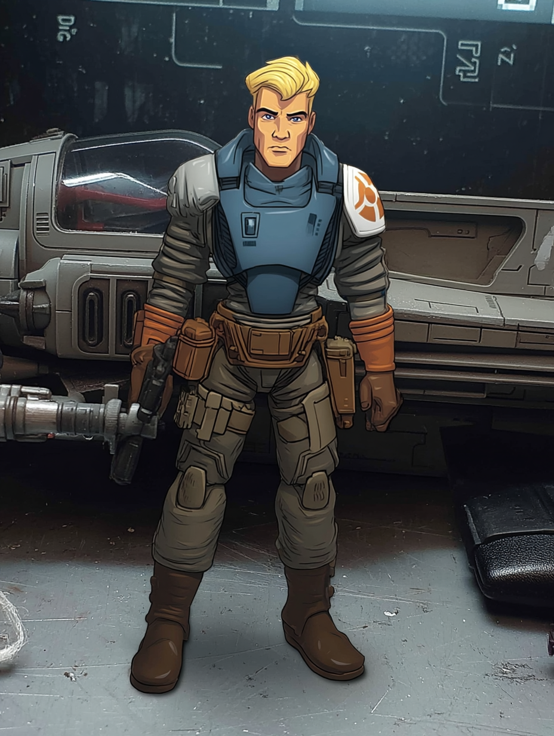
The local defense wing had forty-three fighters when Dakk joined at sixteen. Z-95 Headhunters mostly. A few modified Y-wings for bombing runs. One precious ARC-170 they saved for emergencies. The pilots were farmers' children and merchants' sons who wanted to fly more than they wanted to inherit family businesses.
Dakk wanted to fly more than he wanted to breathe. First time in a cockpit, everything made sense. Throttle and stick. Roll and pitch. The mathematics of momentum. The poetry of powered flight. He soloed after six weeks. Made flight leader after six months. Made ace after eighteen months when pirates tried to raid the grain reserves.
Five kills in one engagement. Clean flying. No wasted shots. No unnecessary risks. Just superior positioning and better timing. The pirates fled. The grain stayed safe. The planetary governor himself pinned the ace wings on Dakk's flight suit.
Two years later, the Empire arrived with standardization protocols. Local defense wings were inefficient. Inconsistent. Potentially rebellious. Better to contract Imperial-approved security companies. Better to ensure complete compliance with Imperial authority.
The dissolution meeting took four minutes. An administrator read from a datapad. Forty-three pilots were thanked for their service. Severance packages were explained. Questions were not encouraged. The hangar doors were sealed before sunset.
Dakk kept his flight suit. Nobody asked for it back. He kept his ace wings. Nobody cared about local honors anymore. He did not keep his purpose. That had been locked in the hangar with fighters he would never fly again.
The message came through a veterans' employment board. Experienced pilots needed. Private contractor. He applied because the alternative was farming. The interview was one question on a datapad: "You fly for credits or cause?"
He wrote the truth: "I fly because I am good at it. The cause determines whether I stay."
The response was immediate: "Y-wing available. Hangar 12. Gunner named Cheedo needs a pilot. You fly. He shoots. Kestrel pays."
The Y-wing was older than Dakk. Patched and re-patched. Engines rebuilt at least twice. But maintained. Someone had loved this ship once. Or at least respected it enough to keep it functional.
Cheedo arrived shortly after Dakk, s Rodian. Nervous energy barely contained. Good eyes that tracked everything. They established terms quickly. No extended negotiations. No elaborate contracts. Just an understanding between professionals.
The first mission was escort duty. Medical supplies through contested space. Pirates made one pass. Saw the Y-wing. Calculated odds. Departed. Easy money for no shooting. Dakk appreciated missions where his presence was enough.
The second mission required shooting. Corporate enforcement squad trying to impound a family freighter. Illegal seizure dressed in legal language. Dakk flew patterns. Cheedo disabled their engines with surgical precision. The family escaped. The enforcement squad waited for rescue. Nobody died.
Kestrel's jobs followed a pattern. Help the helpless. Hurt the hurtful. Stay profitable enough to keep flying. Dakk had no ideological investment in rebellion. But he had significant investment in proving the Empire wrong. Local pilots were not inferior. Local solutions were not inefficient. Sometimes a single Y-wing could accomplish what Imperial squadrons could not.
He maintained the fighter obsessively. Every bolt checked twice. Every system tested daily. Maintenance was meditation. Maintenance was control. When everything else was chaos, the Y-wing remained constant. Reliable. Honest.
Cheedo turned out to be the same. The Rodian talked too much in cantinas but never in the cockpit. Made impossible shots but never bragged during missions. Sent most of his earnings home to Rodia but never mentioned why. Professional. Reliable. Honest.
They flew together for eight months. Enough time to develop trust. Not enough time to become friends. That was optimal. Friends complicated things. Partners just needed to perform their roles effectively.
The courier mission parameters were specific. Create a window for the boarding team. Disable escorts without destruction. Precise timing required. Kestrel offered payment that mattered: priority access to a Rebel-friendly maintenance bay with military-grade munitions.
Real parts instead of salvage. Fresh munitions instead of reloads. Mechanics who knew Y-wings instead of general technicians who guessed. The offer was worth more than credits. It was sustainability. Future capacity. Continued flying.
Dakk ran through his pre-flight checklist. Every system responded normally. The Y-wing was ready. Had been ready since he rebuilt her the third time. Would stay ready as long as he maintained her properly.
He thought about his former squadron mates. Some flew for the Empire now. Took Imperial contracts because they needed to fly more than they needed principles. Others had returned to farming. Accepted ground-bound lives because flying for the Empire was worse than not flying at all.
Dakk had found a third option. Fly independently. Choose his missions. Prove daily that local pilots flying local solutions could accomplish what the Empire claimed required massive infrastructure. One Y-wing. One pilot. One gunner. Making differences the Empire said were impossible.
The courier would have military escorts. Trained pilots. Better equipment. Official authority. Dakk had experience. He had Cheedo's shooting. He had a Y-wing that responded to his thoughts faster than his hands. Sometimes that was enough. Sometimes it was everything.
He sealed his helmet. Checked comm channels. Verified weapon systems. Behind him, Cheedo did the same. No chatter. No jokes. No unnecessary words. Just two professionals preparing to do professional work.
The Empire had told him he was redundant. Non-essential. Replaced by better systems. Every successful mission proved them wrong. Every impossible shot Cheedo made proved them wrong. Every credit Kestrel paid proved them wrong.
Soon he would fly against Imperial pilots. Not because he hated the Empire, though he did. Not because he loved the Rebellion, though he might. But because he was good at flying and they had told him he was not good enough.
Ace wings meant nothing to the Empire. But they meant everything to Dakk. He had earned them. Had proved them. Would continue proving them until the Empire admitted their error or he died trying.
The Y-wing's engines hummed. Ready. Eager. Honest.
So was Dakk.

